**INFO 5505 – APPLIED MACHINE LEARNING FOR DATA SCIETISTS**

**Assignment -2**

**Data:**

This data set is a wine quality data set which has 1599 observations and 12 columns. This is open-source data set downloaded from [kaggle](https://www.kaggle.com/uciml/red-wine-quality-cortez-et-al-2009)

The objective of this assignment is to develop a Logistic regression model that can predict the wine quality whether its quality is low quality or high quality

1. **Data Loading**

The data is loaded into a data frame and verified using pandas library as shown below.

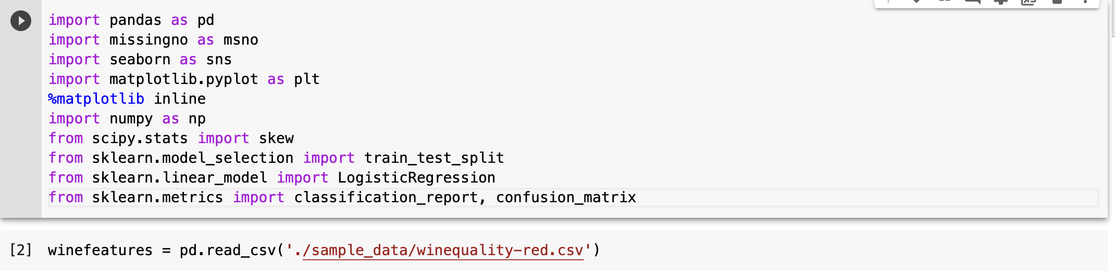

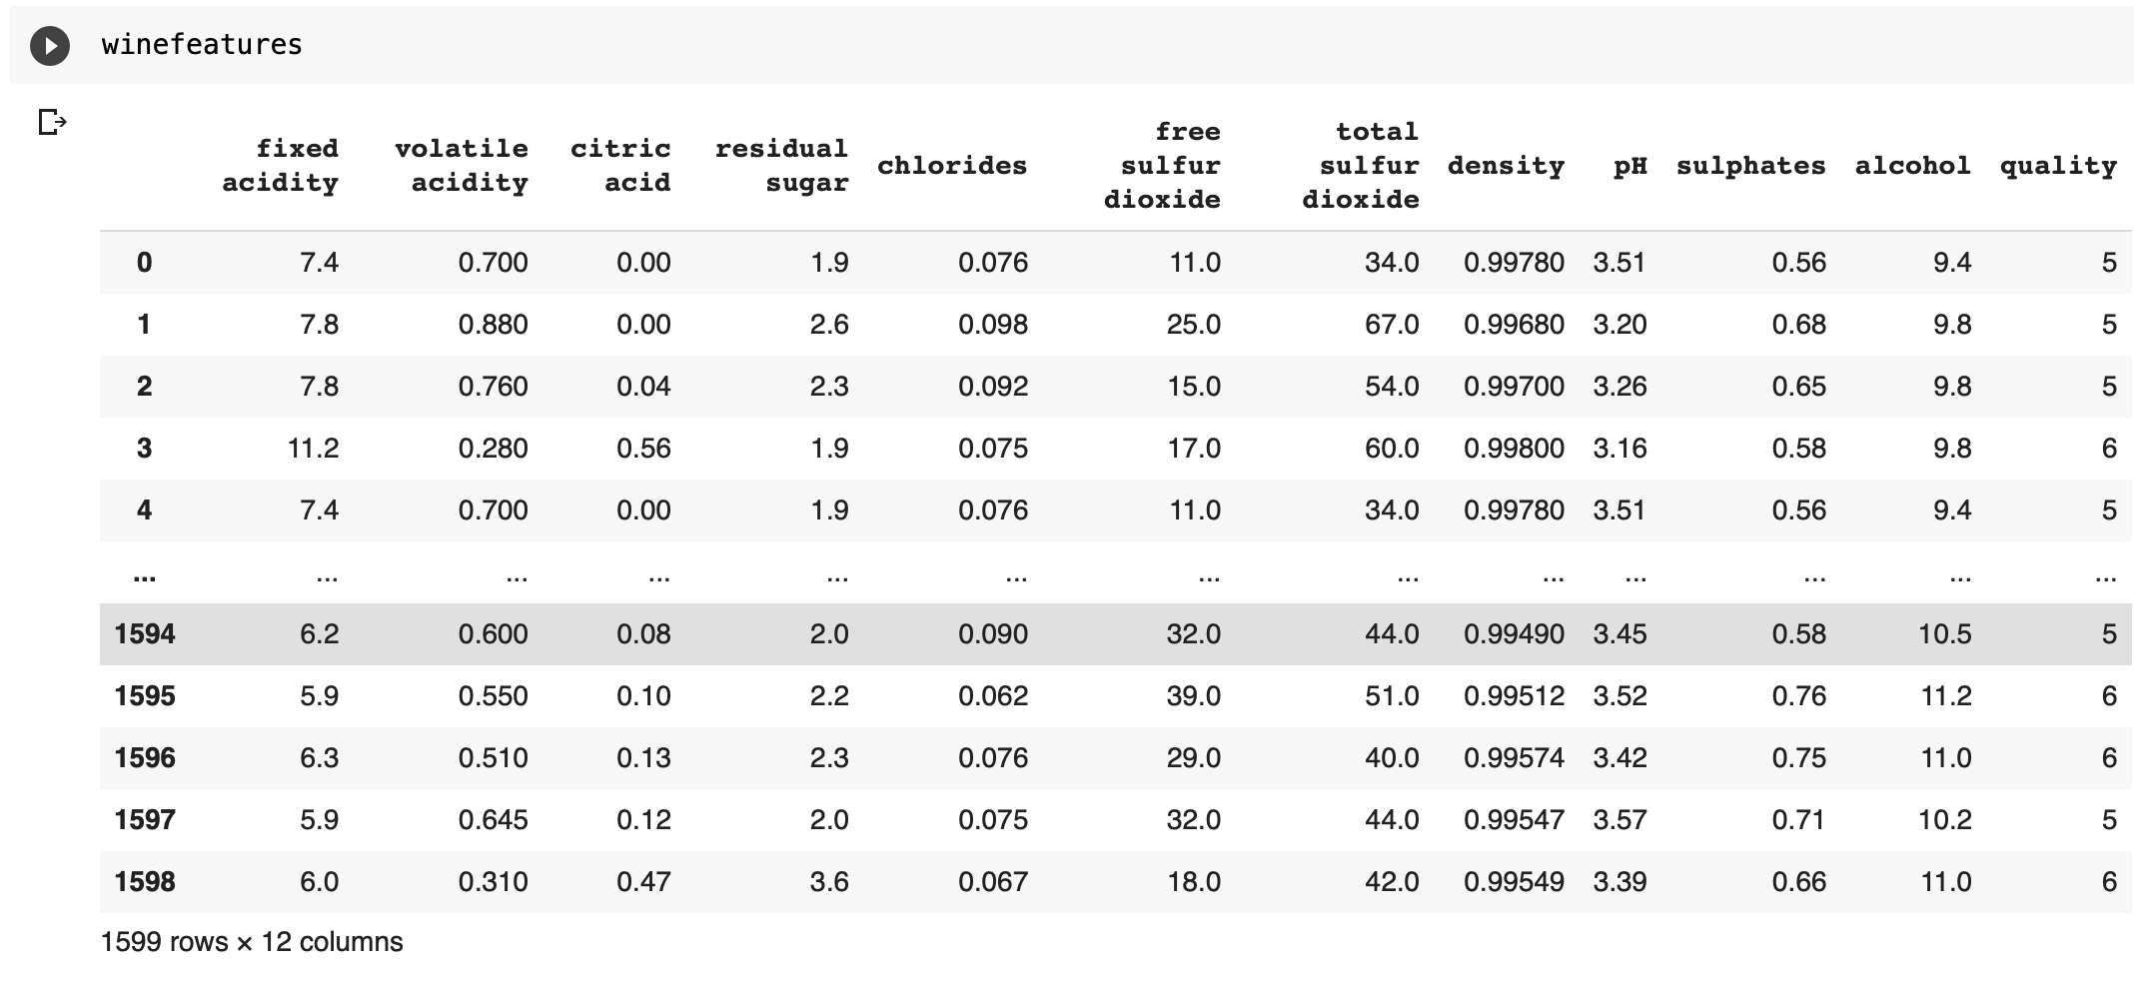

Getting the info of the data set

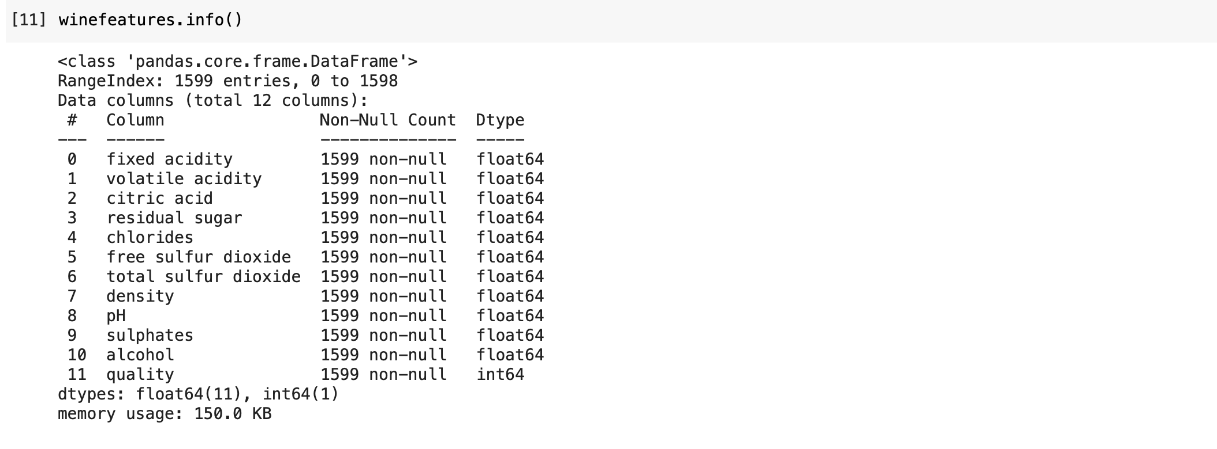

1. **Checking for missing values:**

Number of missing values in the data set is checked using isnull() function of the data set.

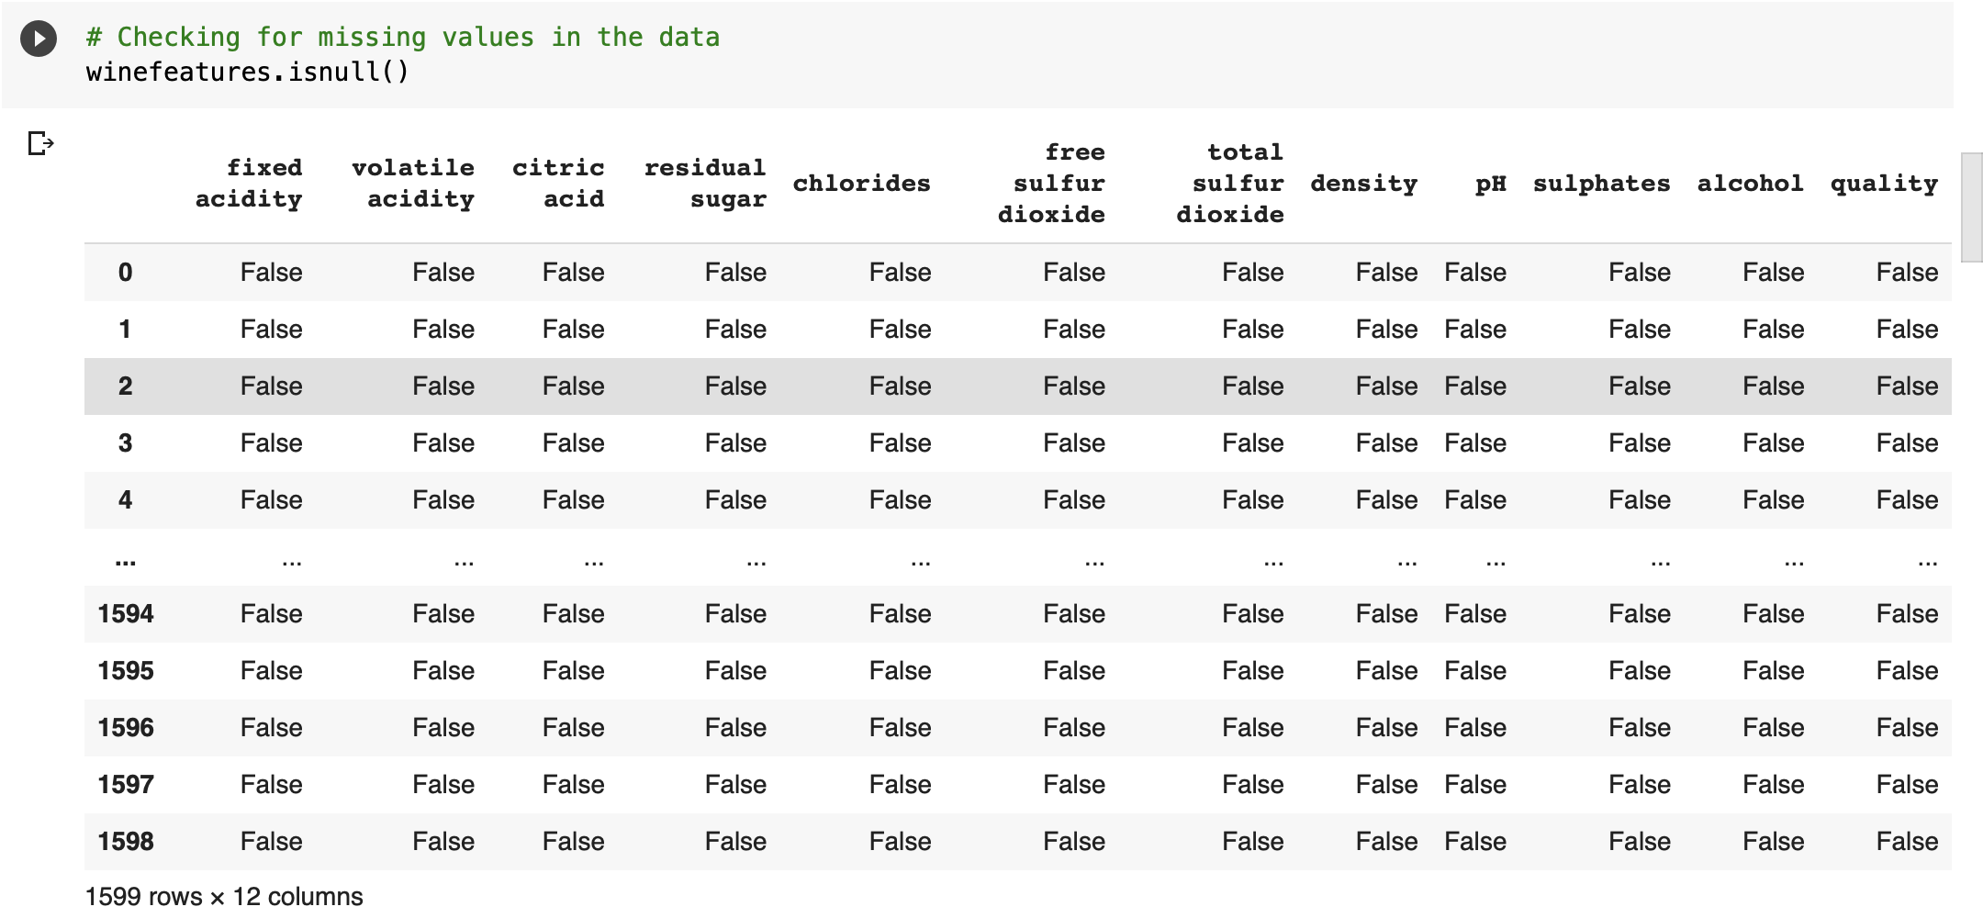

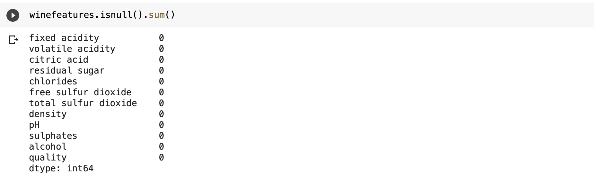

Above results tell that there are no missing values in the data.

Missing values are also checked by using msno matrix as shown below.

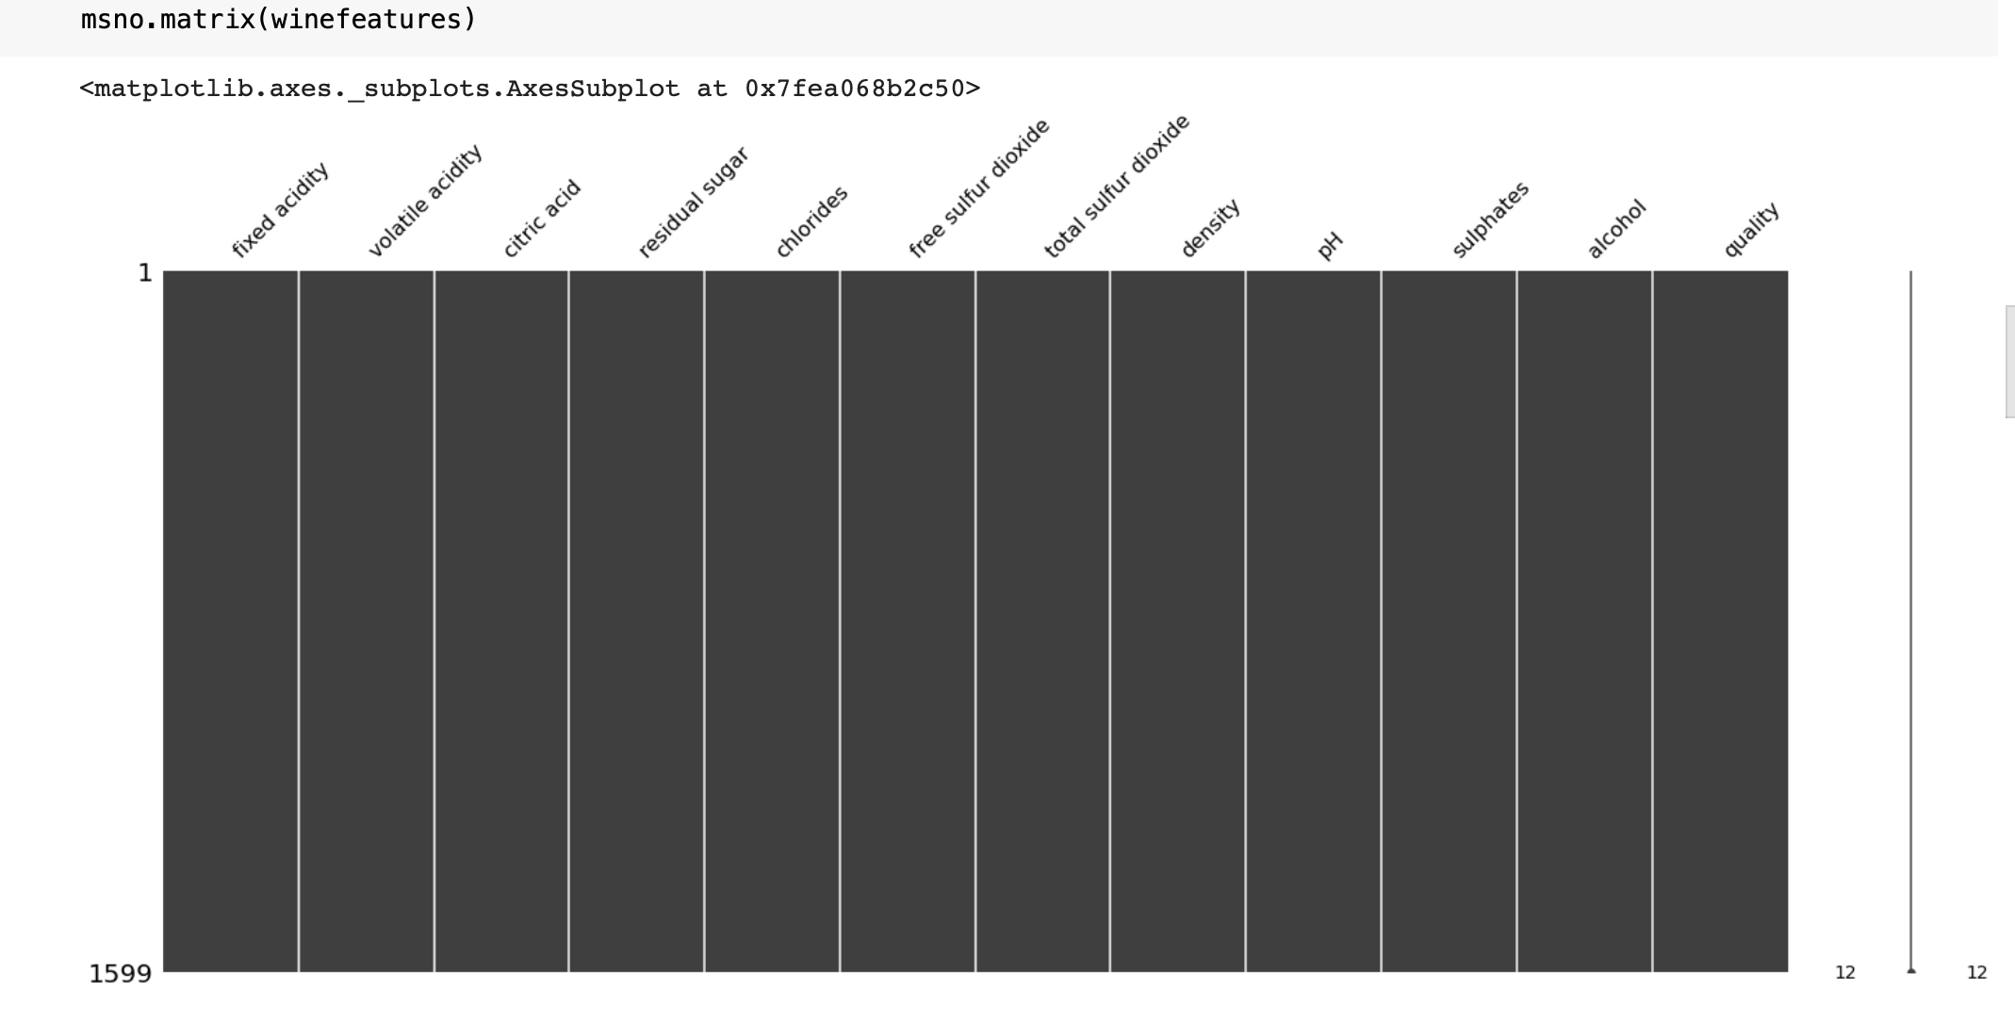

All the bars for each feature are full which says that there are no gaps (missing values) in the given data.

1. **Checking variable distribution**

It is always important to check whether the variables are normally distributed or not. Below visualizations show the data distribution of each variable by using histograms.

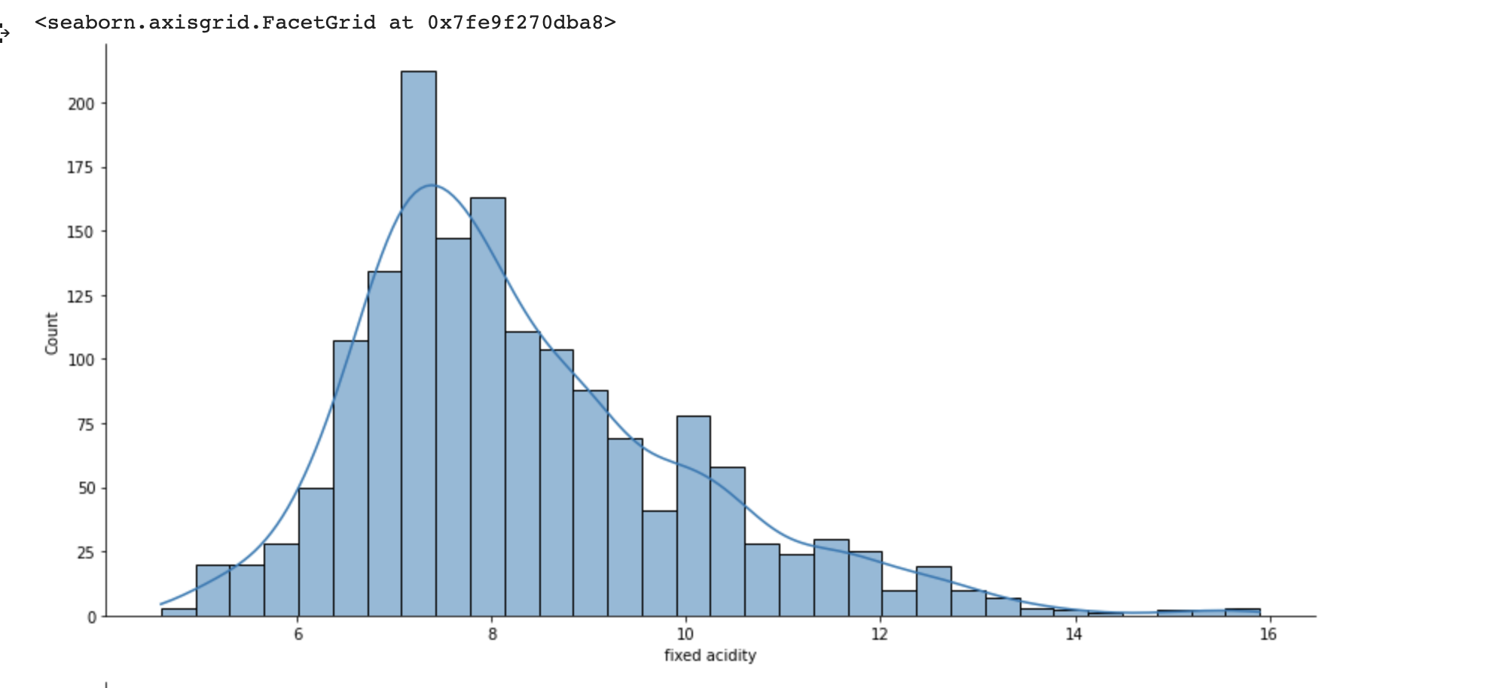

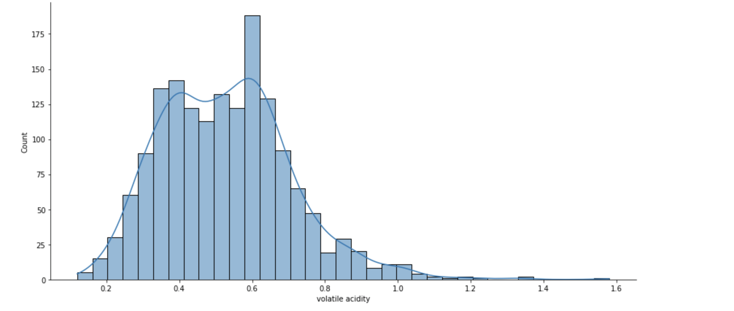

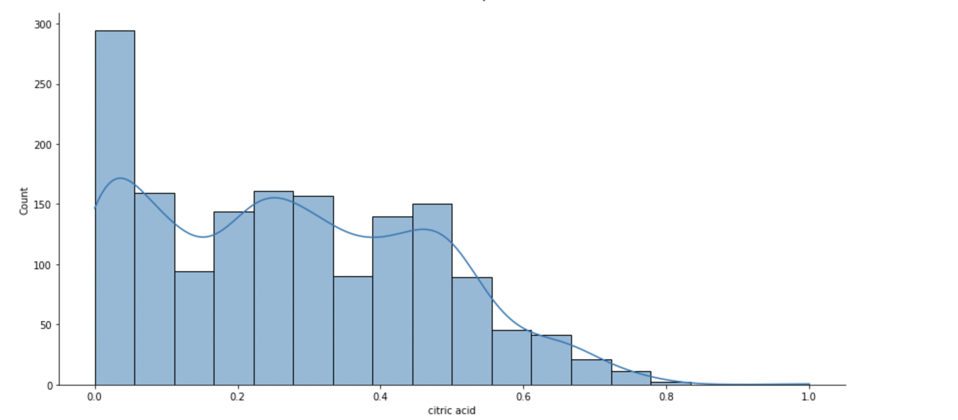

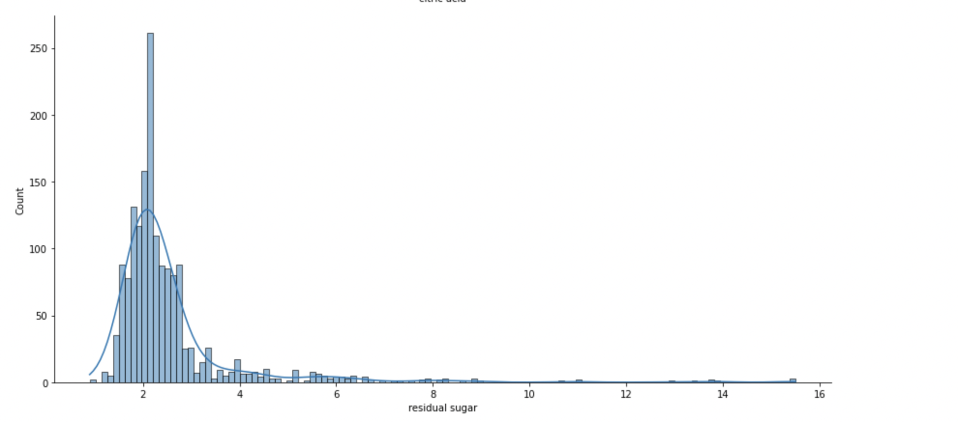

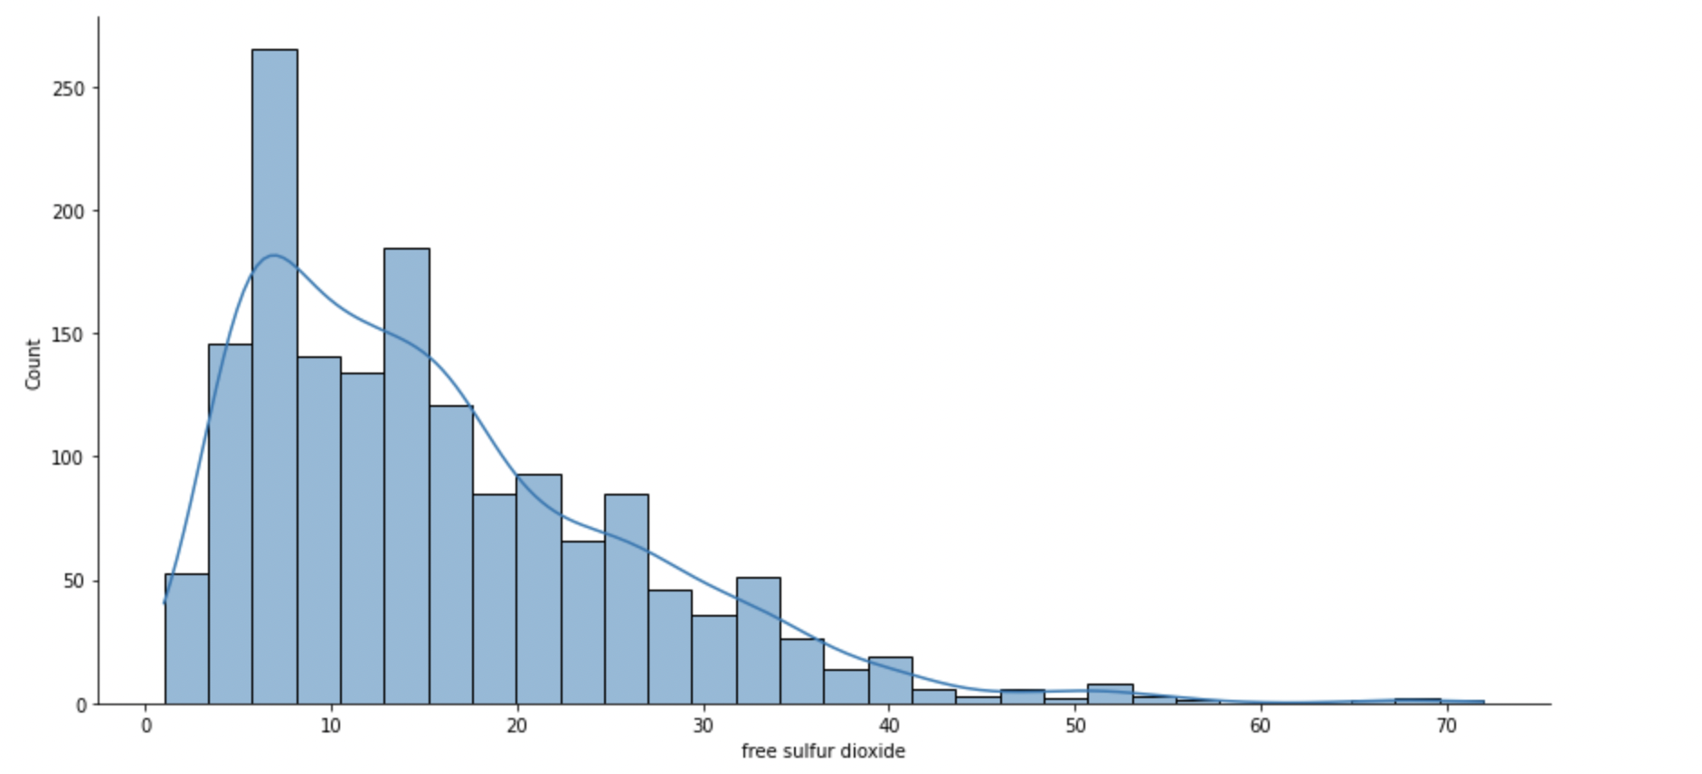

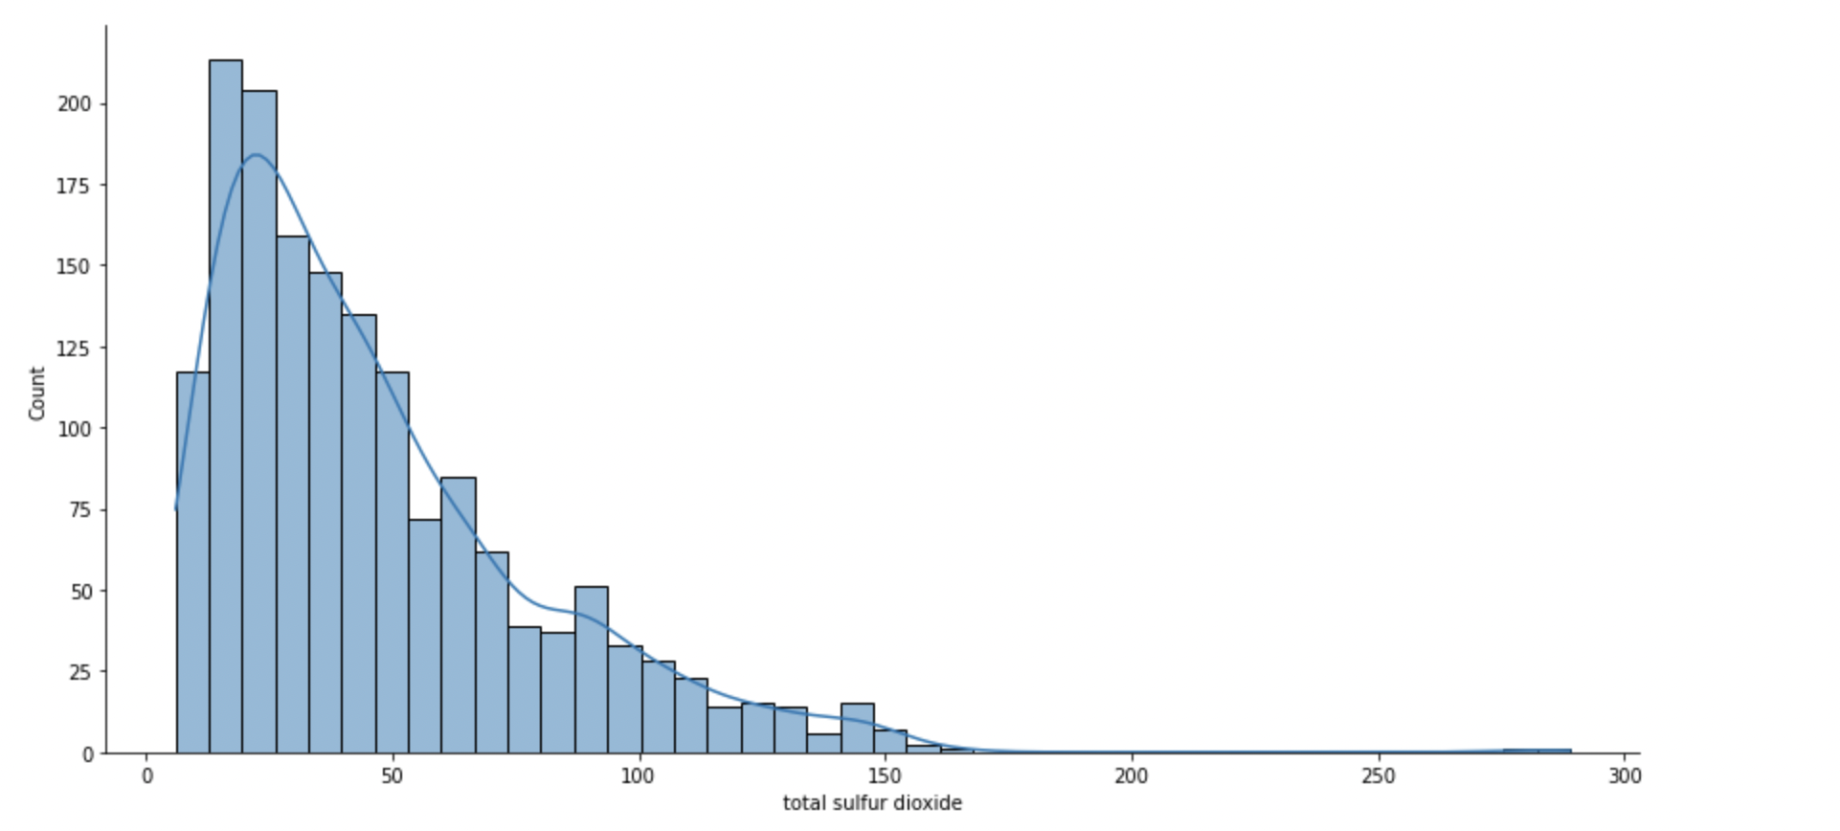

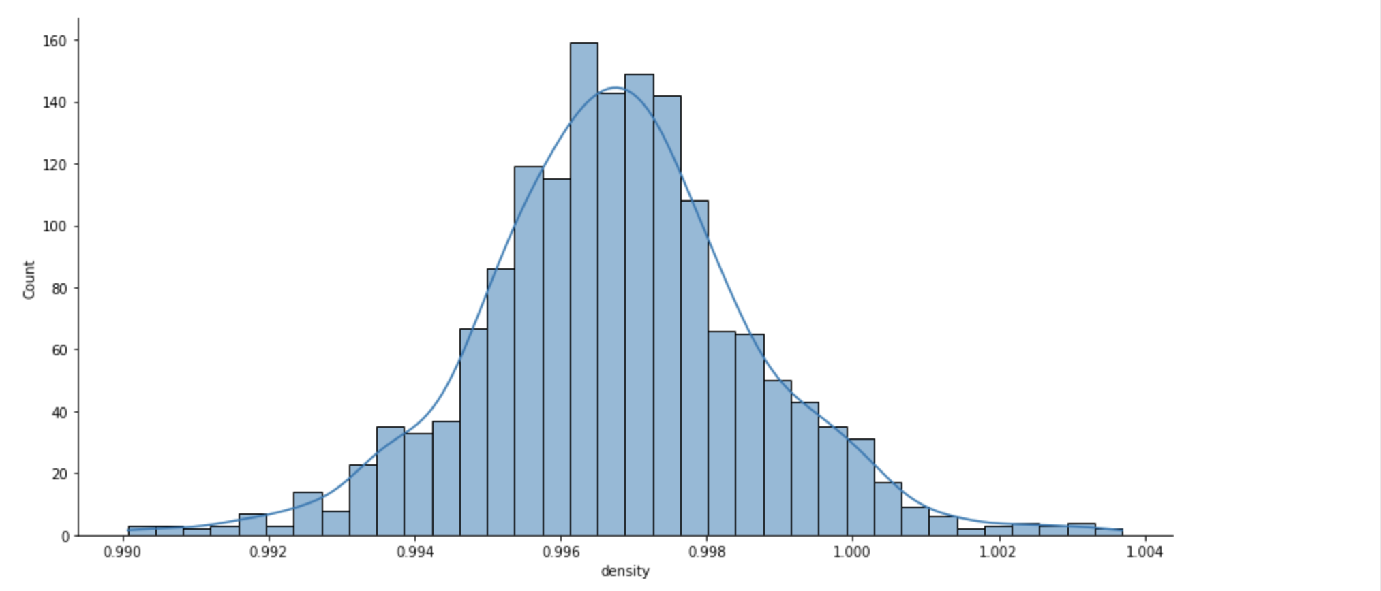

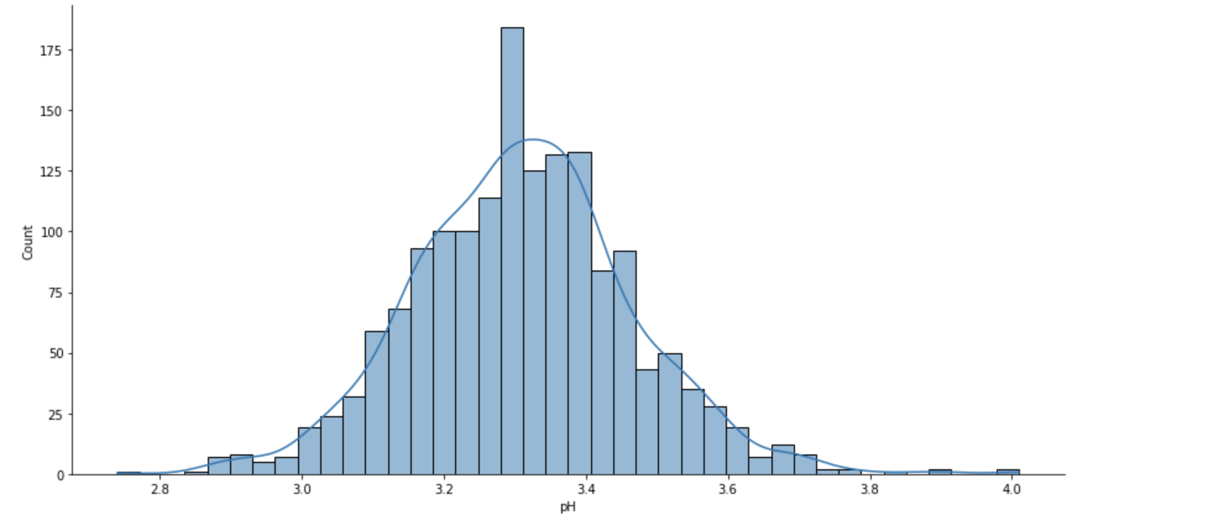

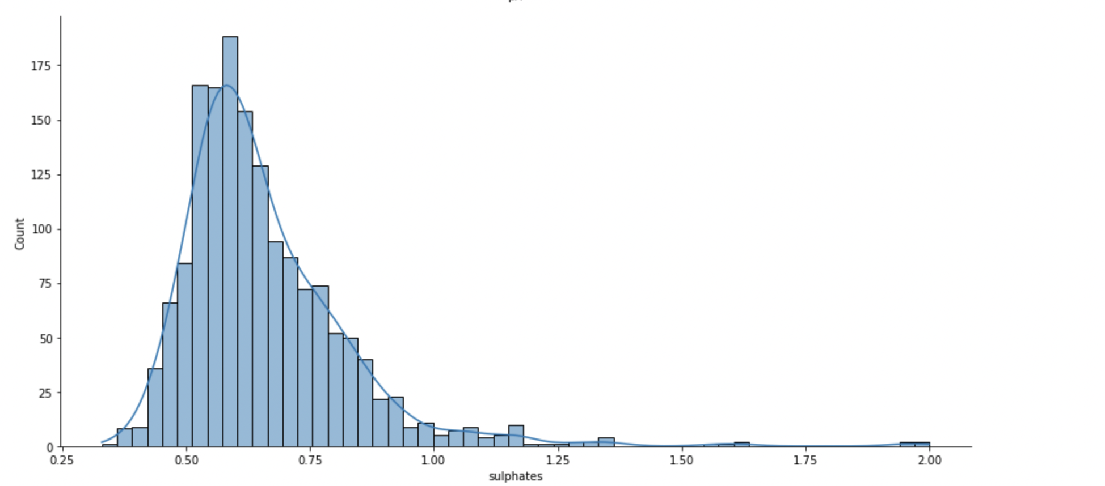

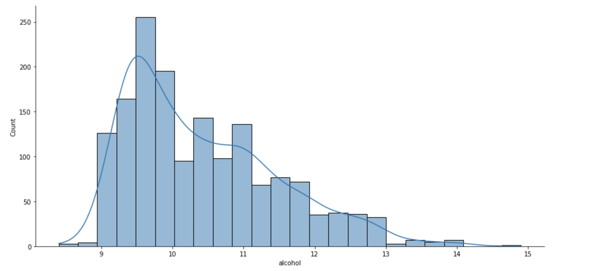

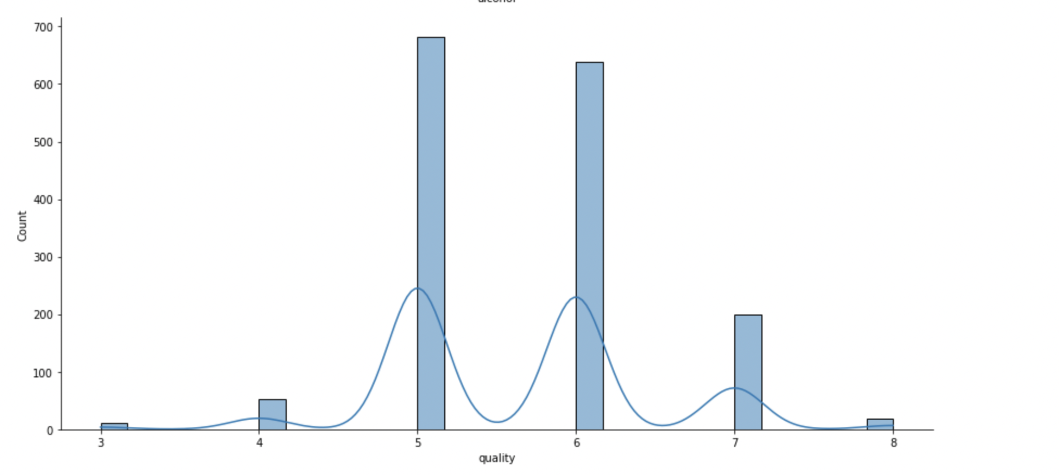

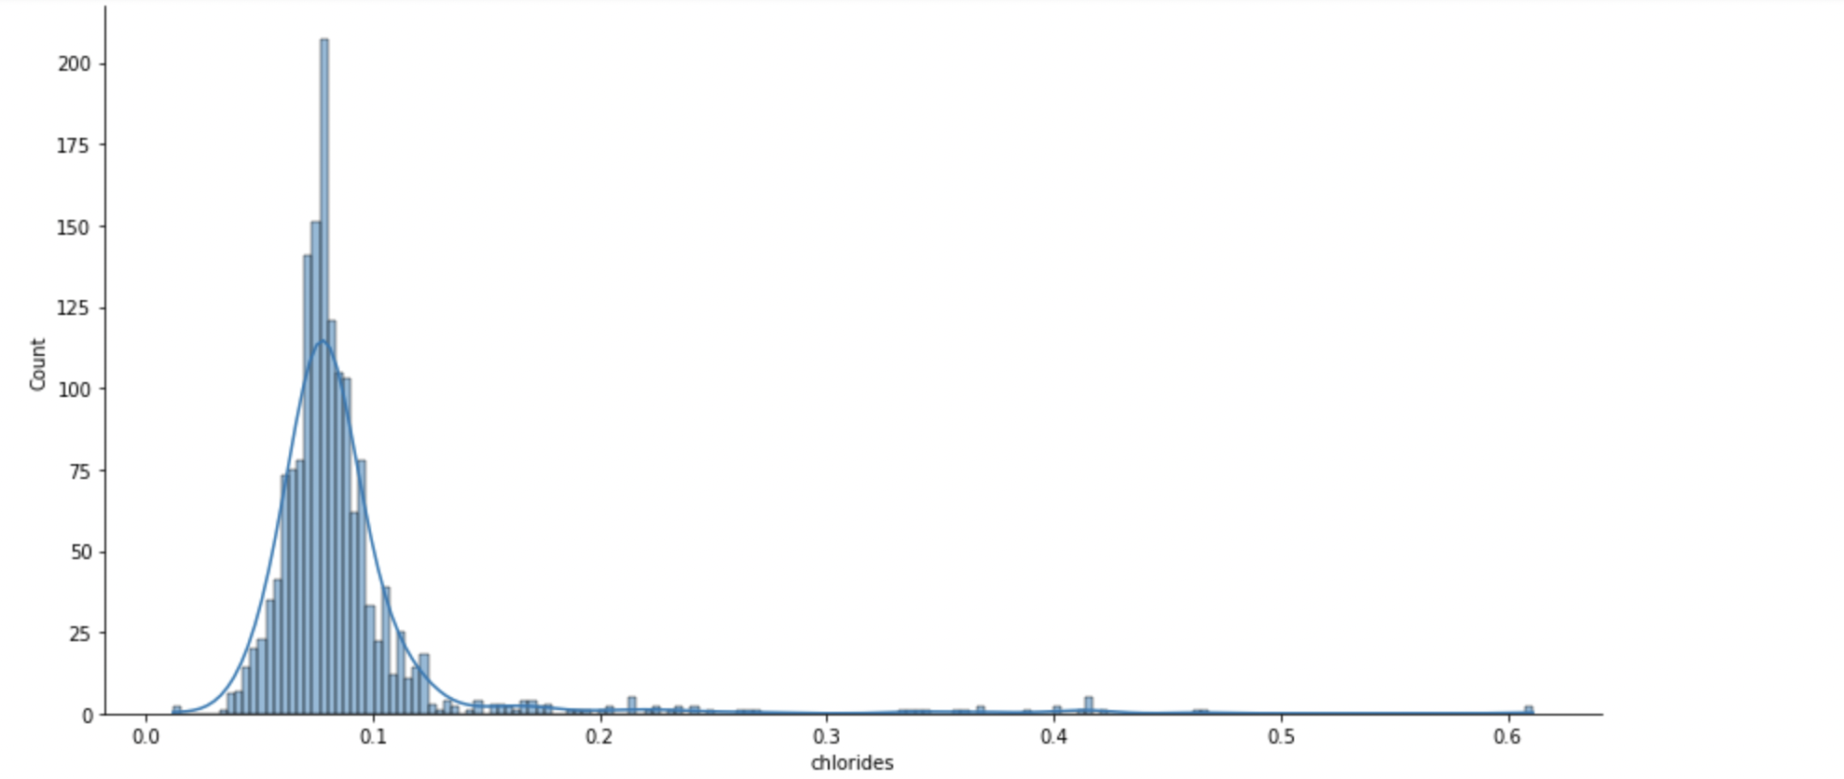

From the above visualizations it can be seen that values of chlorides are right skewed. This is verified by using skew function as shown below.

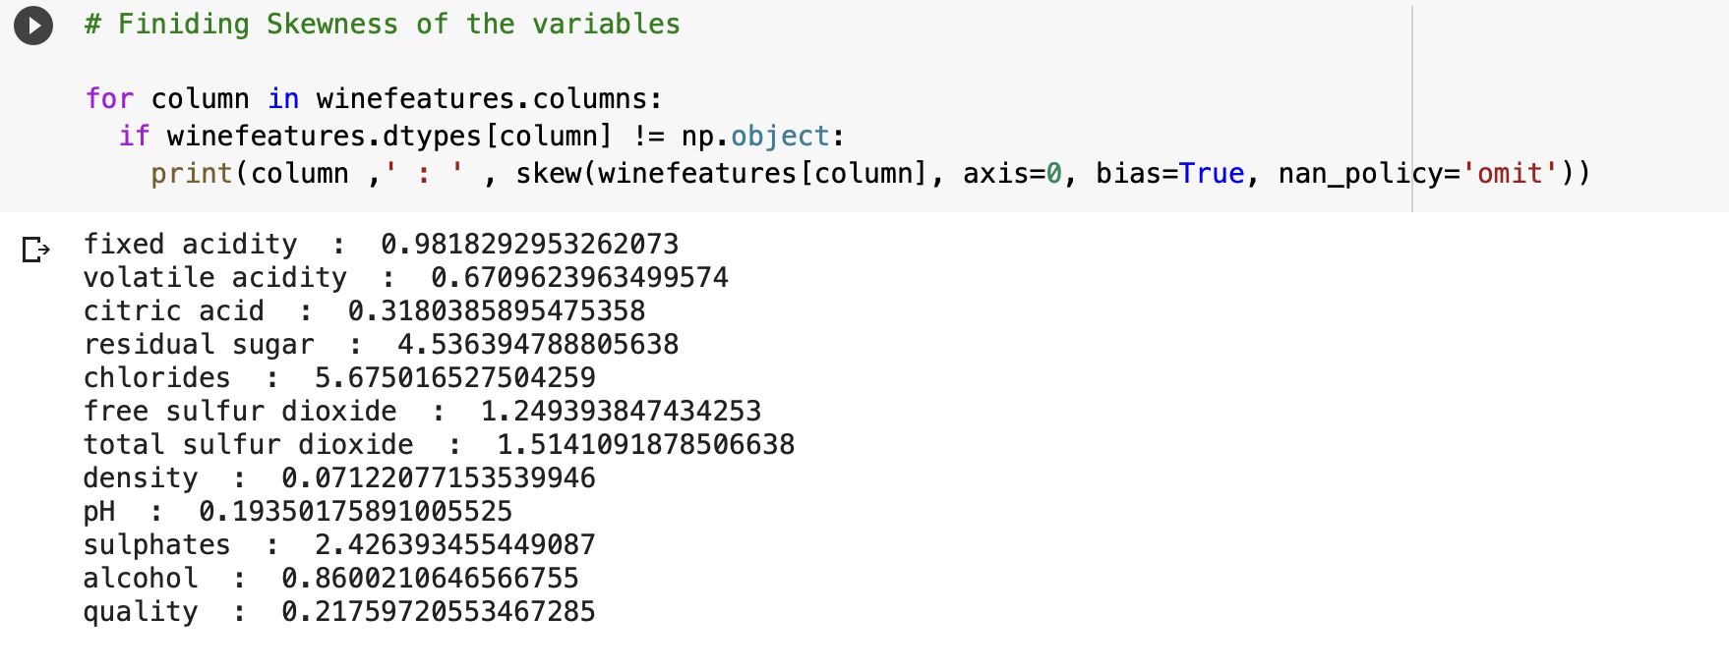

The skewness of chlorides is 5.67 which is more that positive 3 (standard value). So, this variable is log transformed and used for mode development

1. **Finding Correlation between variables.**

It is important to find out the correlation between all the variables in the data set. This is checked by using the heatmap as shown below.

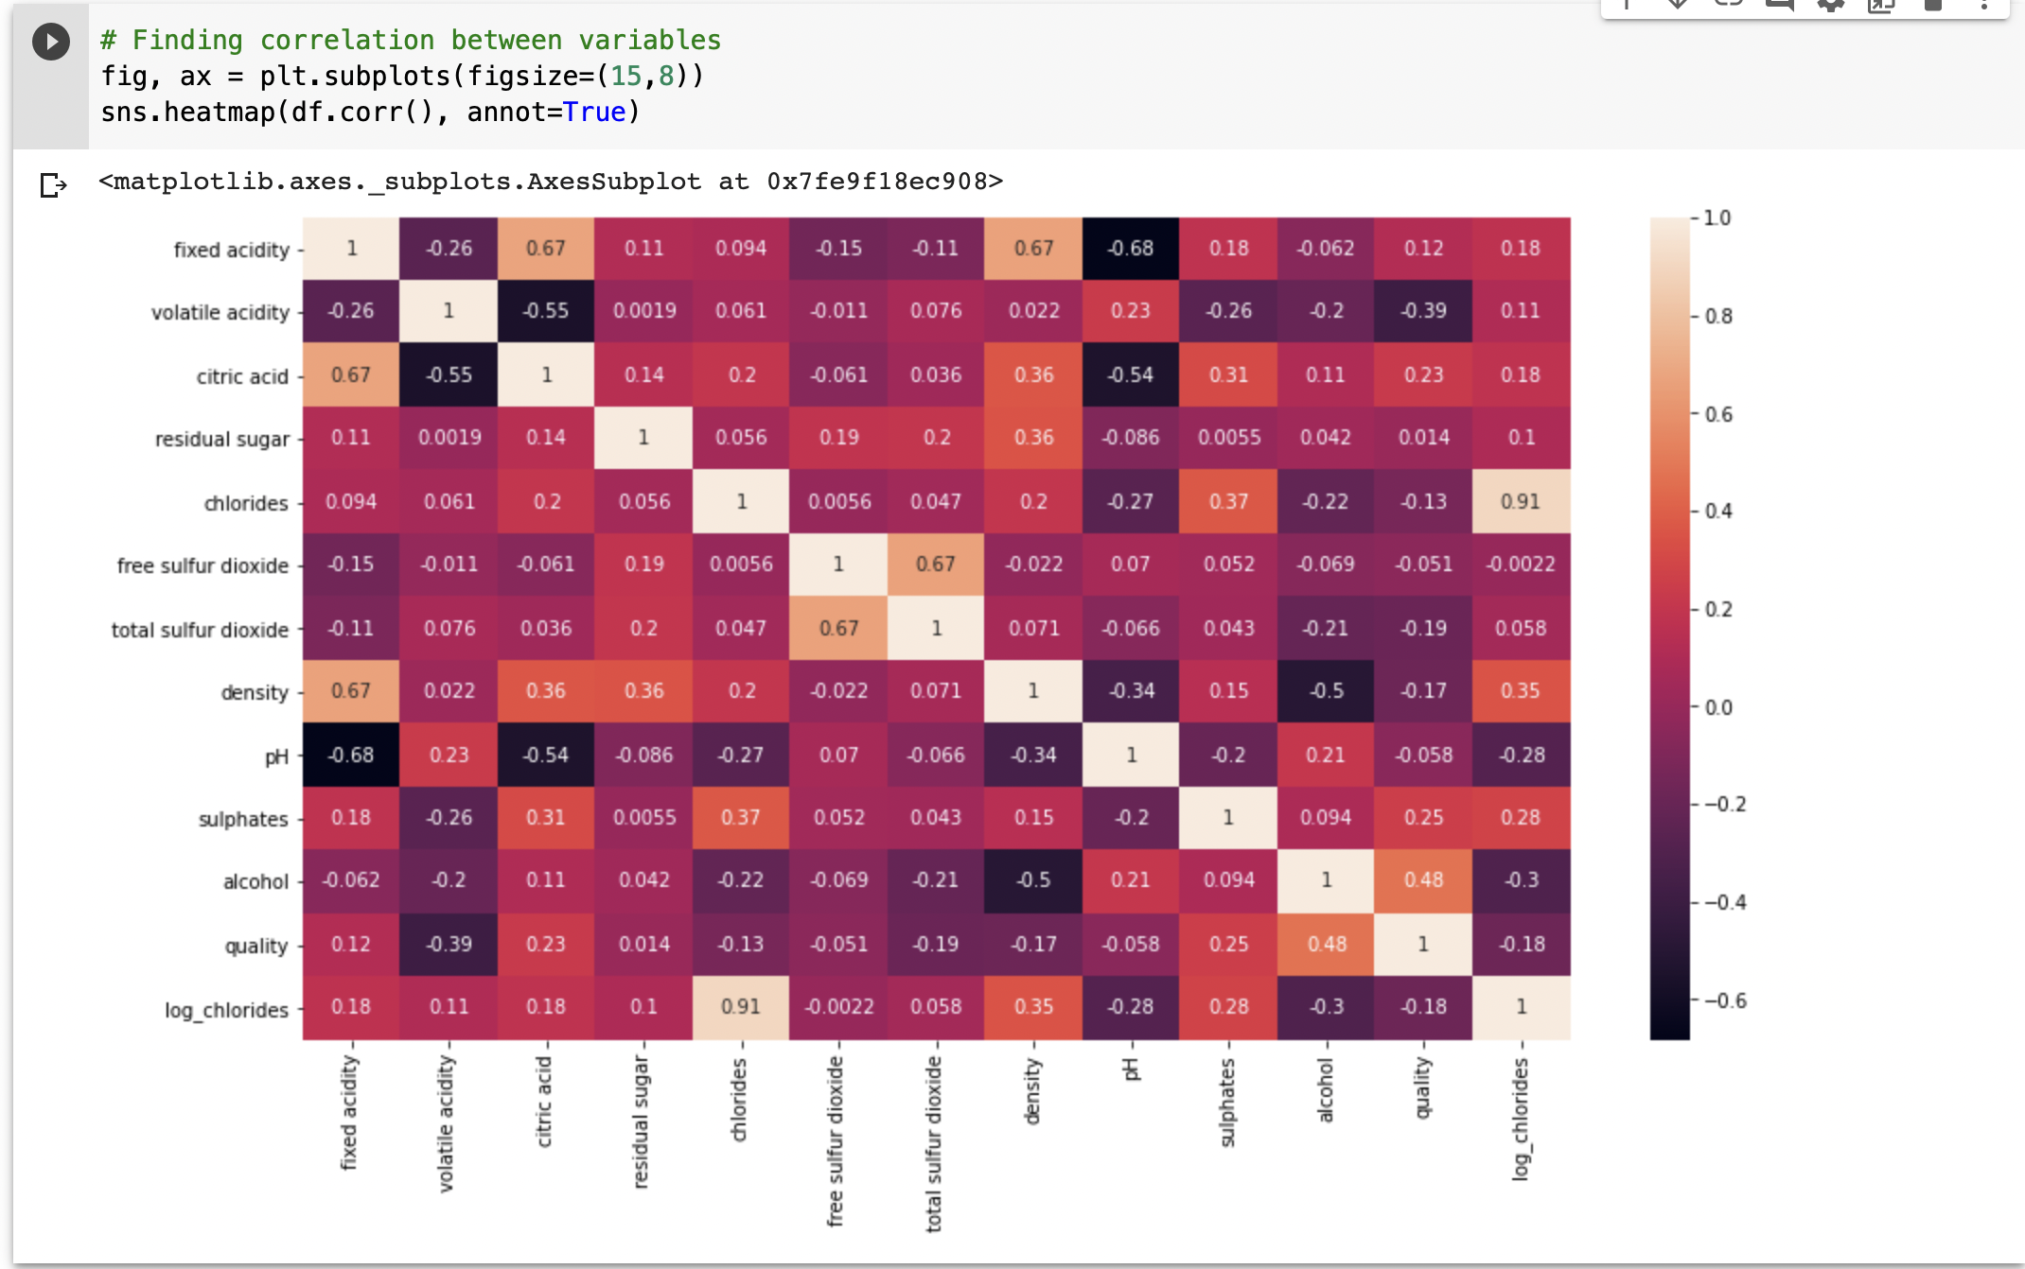

From the above correlation heatmap it can be inferred that wine quality is highly related to alcohol level which is 48%

1. **Preprocessing the data:**

Wine quality is categorized as between 2 and 8. But as we are going to develop a model which predicts the wine quality as two ranges (high quality, low quality). These categories are converted to binary values (0 and 1s).

The values which are greater than or equal to 7 are converted into 1 and other values are converted into 0

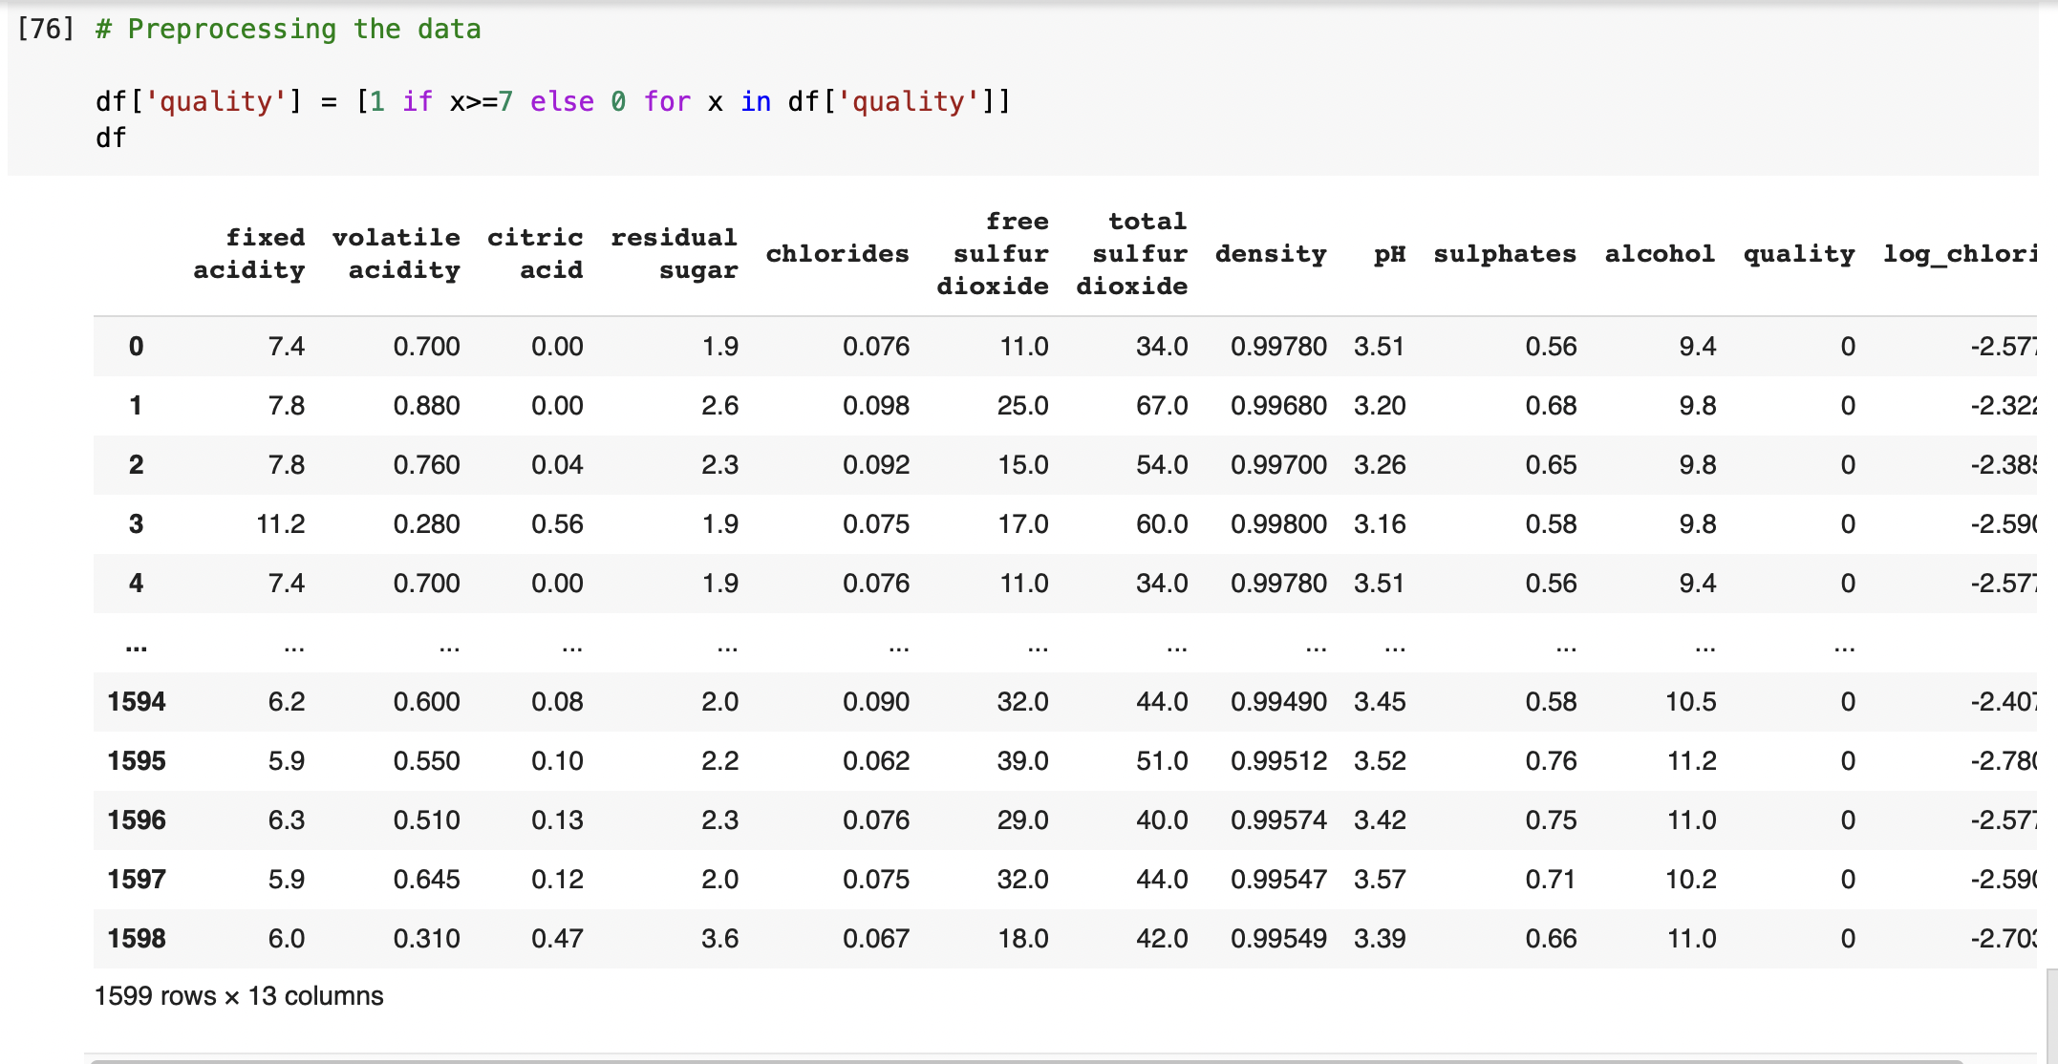

1. **Developing model:**

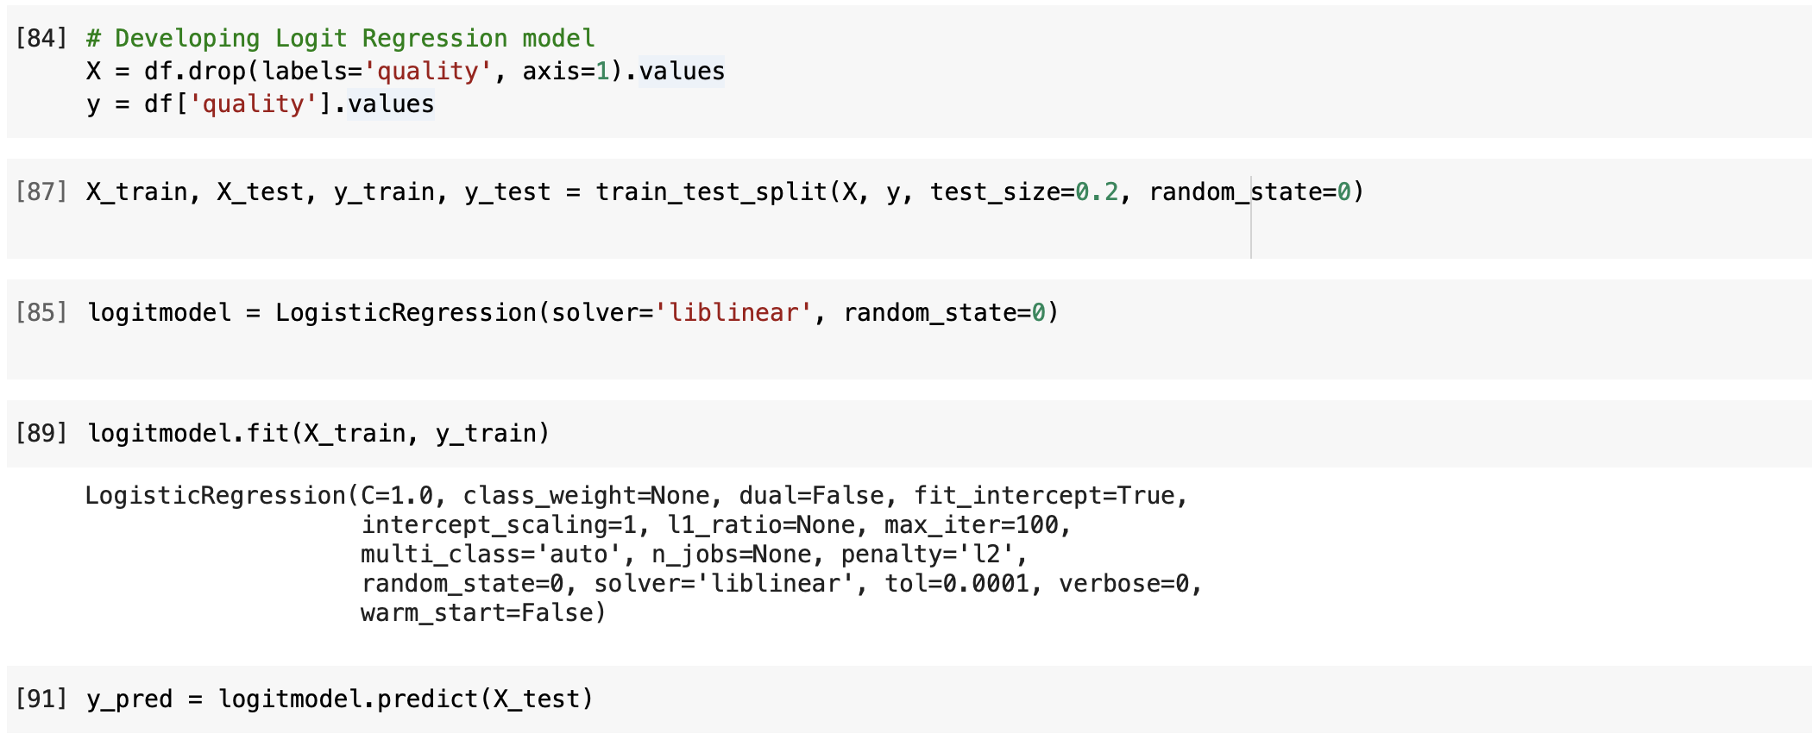

**Finding Test scores**:

**Confusion matrix**

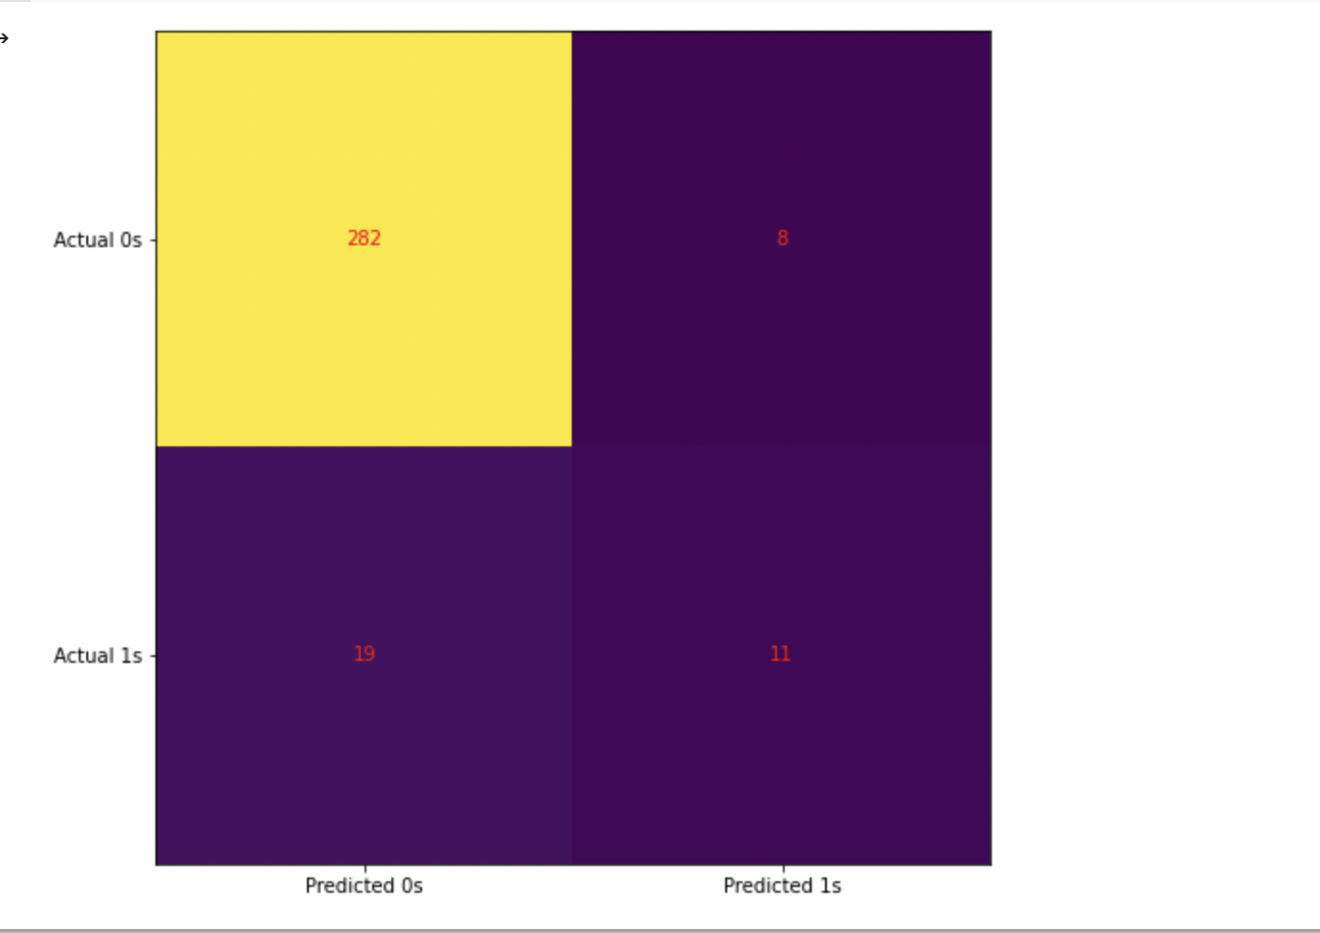

From the above confusion matrix below points can be inferred.

Actually, in our test data there 300 low quality wine (0s) and 30 high quality wine (1s)

Of the 300 low quality wine our model has predicted that 8 were high quality, and of the 30 high quality wine the model has predicted 19 as low-quality wine

**Accuracy of the model:**

The accuracy of the model refers to out of 100 observations how may were predicted correctly. For example, out of 100 observations if 90 observations were predicted correctly then the accuracy is 90%

The accuracy of the model is 91.5% as shown below.

